Read this DISCLAIMER prior to using this Safe Work Procedure.

These procedures have been written by Safety professionals, and not by workers who perform these tasks. They need to be reviewed by workers and customized to match your company’s processes, tools and machines.
Follow these steps:
- Print the procedures
- Have experienced workers (experienced with the tasks) review the procedures and mark up the document with any changes – deletions or additions. The procedures need to reflect your practices.
- Workers to then date and sign the document at the bottom of the SWP as “reviewed by”
- Supervisor to then review the suggested changes and accept or further customize the SWP.
- Supervisor to sign “Approved by” once procedure accurately reflects your company’s procedures
- Make changes to digital copy of procedure and add your company logo. Type in names of reviewers, approvers and dates at the bottom of the procedure and note” Signature on file”
- File all original marked up documents. DO NOT THROW OUT
- The Procedures are now yours.
- Review with WSH Committee and document review
- Train and document your workers according to the tasks they perform.

Do not perform this task Working Alone or in Isolation during the COVID-19 pandemic unless you have been trained and your Employer has implemented precautions.
Photograph(s):  <<<insert equipment or process photo, picture, or diagram here>>>  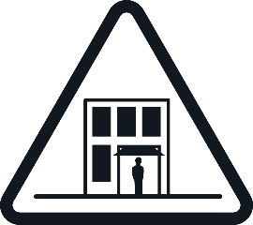 | Identified Hazard(s): |  |  |  | Personal Protective Equipment Required:  Mobile Communication Device  <<<Add or remove Personal Protective Equipment as to your company’s specific procedures or tasks>>>  <<<Specify PPE specific e.g. Nitrile gloves>>>
 | 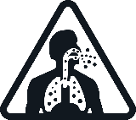 |  | 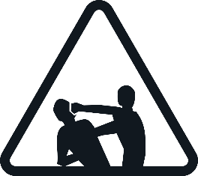
 | <<<insert hazard pictograms and descriptions here. See PDG B-03 chart for examples>>>
Training Requirements: Needs to be customized to your work practices.

- Health and Safety Orientation

Safe Work Practices
Ensure working alone policy is accessible electronically |  | Train both the worker (check-in frequency) and the designated contact person (procedure if check-in not received)
Disinfect workstation and equipment regularly |  | Have mobile contact devices charged and accessible
Pre-schedule check-ins |  | Regularly wash hands for a minimum of 20 seconds
Interact with your coworkers via chat regularly |  | Ensure all staff contact information is current
Guidance Document & Reference Information:

Reference your Safety Management System/Program
Any other relevant legislation (federal or provincial references when working outside of Manitoba)

S2SA SWP011[V1.0]
Workplace Safety and Health M.R. 217/2006
- Part 2 General Duties
- Part 4 General Workplace Requirements
- Part 9 Working Alone or in Isolation
- COVID-19 SWPs
- Company pandemic plan

Safe Work Procedures
- Establish an effective communication system based on the type or work and location
- Telephone or cell phone
- Other form of two-way communication
- Mobile / Computer Application
- Email
- Pre-schedule check ins with designated contact person: morning, lunch, and end of shift
- Worker to complete check-in as scheduled. For higher risk work, arrange for more frequent check-ins or use a different media source such as video check-ins using Microsoft Teams, Skype, Zoom, etc.
Higher risk work may include:
- Worker resides in high crime area
- Worker is involved in a domestic situation
- Worker resides in area with outbreak of COVID-19
- Another member of the worker’s household has tested positive for COVID-19
- Worker is considered a vulnerable worker

For higher risk employees, use video chat option (Microsoft Teams, Skype, Zoom, etc.) to conduct check-ins. Use this opportunity as a wellness check.
Higher risk employee (in this application) may include:
- Worker has voluntarily shared they are susceptible to depression
- Worker has voluntarily shared they struggle with mental health
- Worker is alone without a support system
- If the worker fails to check in at the scheduled time, the designated contact person needs to reach out and try to make contact with the worker. If communication is not made in the time frame set out by the Working Alone or in Isolation Policy, the designated contact person is to notify a supervisor
- Supervisor is to refer and follow the Working Alone/In Isolation policy and/or Emergency Response Plan. This may include alerting emergency services
- Conduct video (wellness) chats/meetings with all team members on a regular basis. Can be done individually or as a team.

Revisions to the document made by: |  | Date:
Reviewed by: |  | Date:
Reviewed by: |  | Date:
Reviewed by: |  | Date:
Approved by: |  | Date:

