Read this DISCLAIMER prior to using this Safe Work Procedure.

These procedures have been written by Safety professionals, and not by workers who perform these tasks. They need to be reviewed by workers and customized to match your company’s processes, tools and machines.
Follow these steps:
- Print the procedures
- Have experienced workers (experienced with the tasks) review the procedures and mark up the document with any changes – deletions or additions. The procedures need to reflect your practices.
- Workers to then date and sign the document at the bottom of the SWP as “reviewed by”
- Supervisor to then review the suggested changes and accept or further customize the SWP.
- Supervisor to sign “Approved by” once procedure accurately reflects your company’s procedures
- Make changes to digital copy of procedure and add your company logo. Type in names of reviewers, approvers and dates at the bottom of the procedure and note” Signature on file”
- File all original marked up documents. DO NOT THROW OUT
- The Procedures are now yours.
- Review with WSH Committee and document review
- Train and document your workers according to the tasks they perform.

Do not use this Working from Home Ergonomics (Covid-19) unless you have been trained
Employees are required to follow this procedure when performing this task.
Photograph(s):  <<<insert equipment or process photo, picture, or diagram here>>> |  | Hazard(s):  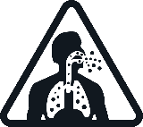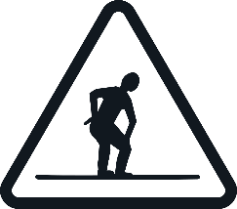  <<<insert hazard pictograms and descriptions here. See PDG B-03 chart for examples>>> |  | Protective Equipment Required:  <<<Add or remove Personal Protective Equipment as to your company’s specific procedures or tasks>>>  <<<Specify PPE specific e.g. Nitrile gloves>>>
Training Requirements: Needs to be customized to your work practices.
- Health and Safety Orientation
- Task Specific Training
- S2SA SWP011 Working Alone or in Isolation
- Working Alone or in Isolation Policy

Safe Work Practices
Use virtual meetings instead of face to face. |  |  | Set up your home workspace like your work office.
Stick to your usual work schedule. |  |  | Interact with your coworkers via chat regularly.
Get up and move every hour for at least a minute. |  |  | Disinfect office supplies before bringing home.
Guidance Document & Reference Information:

Reference your Safety Management System/Program
Any other relevant legislation (federal or provincial references when working outside of Manitoba)

Workplace Safety and Health M.R. 217/2006
- Part 2 General Duties
- Part 4 General Workplace Requirements
- Part 9 Working Alone or in Isolation
- Part 10 Harassment
- Part 12 Violence in the Workplace

Picture Illustration | Safe Work Procedures
 | If you have the ability to work at home during this covid-19 pandemic. Follow the below steps to ensure a comfortable and ergonomic desk setup. If you are bringing your office equipment in from the office, ensure that you disinfect it all before bringing it home.
 | Ensure to practice physical distancing while working at home. Encourage virtual meetings (telephone/video conferencing) to reduce prolonged, close contact between individuals.
 | Check in with your Manager/Supervisor as per your working alone policy at the beginning and end of the day at a minimum.
 | - ADJUST YOUR CHAIR: adjust height to ensure your elbows are bent to 90 degrees. If needed you can use a footrest or reem of paper.
- ADJUST YOUR MONITOR: your monitor should be arms length away from you. Raise it so that the top of the screen is inline with your eye level. Use a riser or reems of paper.
Two Monitors: have them lined up so that you are in the middle of them. Laptop, use a kickstand and attach a keyboard and mouse.
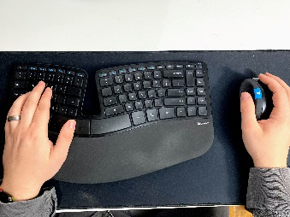 | - MIND YOUR KEYBOARD & MOUSE: where your hand lay on the desk is where your keyboard should be. Your mouse should be right next to it.(move from your elbow not your shoulder)
 | - POSITION YOUR PHONE: your phone should be on your non writing side, so that you do not have to cradle it causing neck pain. If you are on the phone a lot, consider using a headset or place calls on speaker phone if using a cell phone.
- MOVE (& STRECH): after ten to fifteen minutes all of us tend to start to slouch. Some exercises to consider while at your desk:
CHIN TUCK: bring your chin towards your neck and outwards.
NECK STRECH: bend head to one side, and gently pull your head further with your hand.
SCAPUTLA RETRACTION: bring your shoulders back and forth
PEVLIC TILT: bring your upper torso forward and back while sitting.
GET UP: every hour, get up and walk, go get a snack, water, just move.

Revisions to the document made by: |  | Date:
Reviewed by: |  | Date:
Reviewed by: |  | Date:
Reviewed by: |  | Date:
Approved by: |  | Date:

